User’s Manual for thermal simulation software based on Excel (TSE tool)

- Range of use

The TSE tool is not intended to replace Coratherm or Esatan/ Esarad for the detailed simulation of spacecraft thermal behaviour as required for CDR or in the preparation of the thermal balance test in thermal vacuum. Its purpose is to allow fast assessment and comparison of technical solutions.

In first approach, one should limit the number of thermal nodes to 100.

- Physics

The version 2 of the TSE tool handles conduction , radiation and heat transportation via monophasic loops. Version 3 shall also be able to treat also radiative interaction inside spacecraft cavities.

- Definitions, formulas, sign rules, iteration process.

3.1 definitions

  - the subject of the calculation is the temperature in °K of a thermal node

  - a thermal node is linked to a physical entity. It can be the baseplate of an equipment, the wall of a heat-pipe, the deep space.

  - a thermal node is representing the average temperature deemed homogeneous over the all the physical entity it represents

3.2 Conduction

- the heat flux (W) occurring through conduction between two nodes is expressed as follows:

- HFC = Cij * (Tj-Ti) [1] with :

- Ti = temperature of node “i” in °K

- Tj = temperature of node “j” in °K, “i” different from “j”

- Cij = conduction coefficient between node “i” and node “j”, Cij in (W/ °K), and Cij = Cji

- The conductive heat flux is positive for the node “i” if Tj is grater than Ti

3.3 Radiation

- the heat flux (W) occurring through radiation between two nodes is expressed as follows:

- HFR = (Rji *TjE4) - (Rji * TiE4) [2] with:

- Ti = temperature of node “i” in °K

- Tj = temperature of node “j” in °K, “i” different from “j”

- Rij = radiation coefficient between node “i” and node “j”, Rij in (W/ °K), and Rij different from Rji.

- Excluding in a first assessment any radiative interaction between nodes of the spacecraft or having to deal only with parallel plates or coaxial tubes gives Rij = Rji. [3]

- Then, the radiative heat flux is positive for the node “i” if Tj is greater than Ti

3.4 Dissipation

Di is the heat dissipation in node I (W). Di is positive for standard electronic equipment (no cooling machine or no cooling phenomenon like evaporation) [4]

3.5 Sun Impact

Si is the incident sun heat flux (around 1400 W/m2). It is always positive [5]

3.6 Energy balance

3.6.1 Nodes except monophasic fluid loop

The energy balance for node “i” writes , according to [1 ] to [5] :

  - 0 = ( Σj Cij * (Tj-Ti)) + (Σj Rji *TjE4 - TiE4)) + Di + Si [6]

  - if n is the iteration step number n and n+1 the next iteration step, one can write, with a great probability of convergence:

  - 0 = (Σj Cij * Tj,n) – (Σj Cij * Ti,n+1) + (Σj Rji *Tj,nE4) - (Σj Rji *Ti,nE3*Ti,n+1) + Di + Si [7]

  - and hence: Ti,n+1 = (Σj Rji *Tj,nE4) + (Σj Cij * Tj,n) + Di + Si [8]
(Σj Rji *Ti,nE3) + (Σj Cij )

- convergence is eased by the fact that when Ti, n+1 is very near from Ti,n, then the effects on the energy balance of the decomposition according to [7] are becoming 0.

3.6.2 Nodes representing the monophasic fluid loop

The monophasic loop is storing heat via temperature increase of the liquid flowing through it and therefore the temperature of each fluid node is depending of the temperature of the node situated immediately upstream via the following relationship:

T if = Tf jf + (Σ if,j HFCVif,j) / (mi.dot * Cpi) [ 9]

With:

T if = temperature of fluid node i, to be calculated

T jf = temperature of fluid node j situated immediately upstream of i

mi.dot: mass flow valid for node i (Kg/s)

Cpi : capacitive heat valid for node i (J / Kg*°K)

HFCVif,j is the heat flux (the sum of heat fluxes) exchanged by i through the fluid loop tube with any other node j (except the fluid nodes).

HFCVif,j = Kif, j * (Tj-Tif) with :

Kif,j = heat transfer coefficient between fluid node and tube external skin (W / °K)

Remarks :

- Cpi varies normally with temperature

- mi.dot may not be the same for all nodes (by-pass activation)

- Kif,j varies with mi.dot, Cpi, tube roughness, diameter, etc…

- Exercises

4.1) Exercise N°1 : small model, no fluid loop
Total 6 nodes simulating the heat transfers in the following chain:

  - node 1: equipment with dissipation 70 W
  - node 2: heat pipe, evaporator side
  - node 3: heat pipe, condensator side
  - node 4: part of outer skin of radiative panel, directly under heat pipe
  - node 5 and 6: part of outer skin of radiative panel, on each side of node 4
  - node 7: deep space at 4°K

4.1.1 ) Input table N° 1
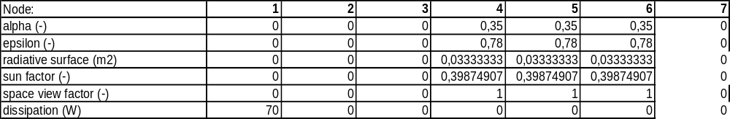
- the sun factor is the cosine of the angle of incidence of sun rays on the considered surface
- node 7 is the deep space, with constant temperature 4 °K

4.2) Input table N° 2 : Conduction Matrix Cij (W/ °K) (none of the Cij values where calculated, all pure imagination)
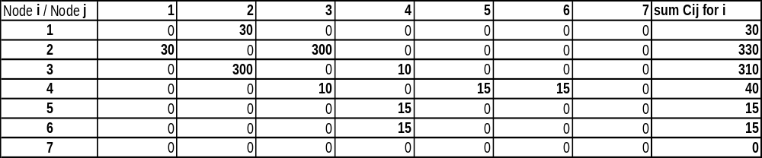
4.1.2) Input table N° 3 : Radiation Matrix Rij (W/ °K E-4)
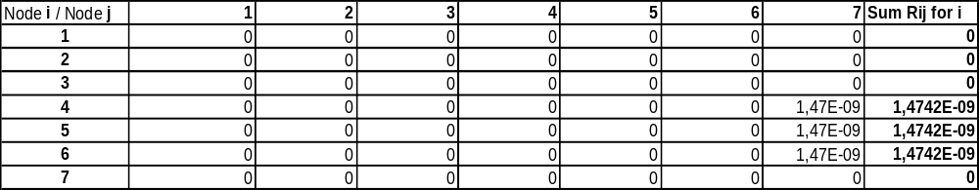
4.1.3) Input table N° 4 : Sun Impact Si (W)

4.1.5 ) Results after ~ 8000 steps iteration :

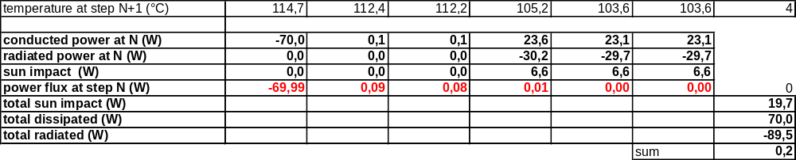

4.2) Exercise N°2 : small model, fluid loop with by-pass, very simplified TUSAT case

Total 13 nodes simulating the heat transfers in the following chain:

  - node 1: payload with max dissipation 1961,5 W (TUSAT N+ S panels, 100% drive)
  - node 2: 1st fluid node, = main stream = convergence of by-pass fluid (node 13) and last cooling fluid node (node 12) , with T2f = (BP*T13f) + (1-BP)* T12f and BP being the by-pass ratio (ratio of mass flows through respectively by-pass and cooling stream).
  - node 3: 2nd fluid node
  - node 4: part of N/S radiative panel
  - node 5: part of N/S radiative panel
  - node 6: part of N/S radiative panel
  - node 7 : deep space at 4°K
  - node 8 : 3rd fluid node (main stream)
  - node 9 : 4th fluid node (main stream)
  - node 10: 1st fluid node in the cooling stream
  - node 11: 2nd fluid node in the cooling stream
  - node 12: 3rd fluid node in the cooling stream
  - node 13: fluid node in the by-pass

4.2.1 ) Input table N° 1
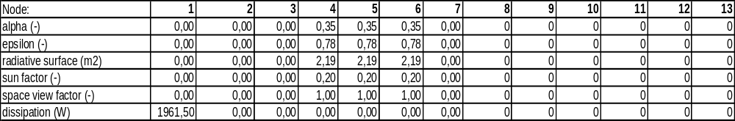
- the sun factor is the cosine of the angle of incidence of sun rays on the considered surface. It has been divided by two w.r.t solstice conditions, because North and South radiative surfaces are not distinguished in this simplified model.
- Total radiative surface is 6,56 m2 (TUSAT IDR-1 results)

4.2.2 ) Input table N° 2 : Conduction Matrix Cij (W/ °K)

- Cij values where calculated as follows:
- Total fluid loop length: 48 m, divided in 3 * 8 m for payload I/F and 3* 8 m for radiator I/F
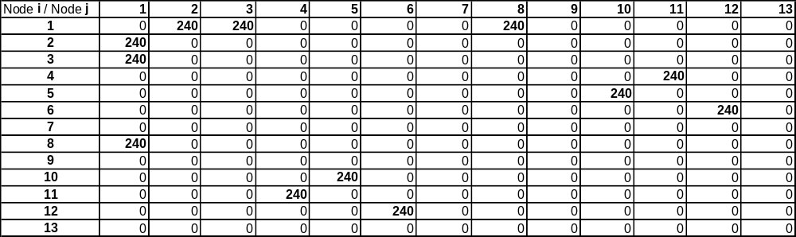
- Linear heat exchange coefficient : 30 W / m* °K (average value according to NPO-PM data), and hence Kif,j = 240 W / °K for all fluid nodes

4.2.2) Input table N° 3 : Radiation Matrix Rij (W/ °K E-4)
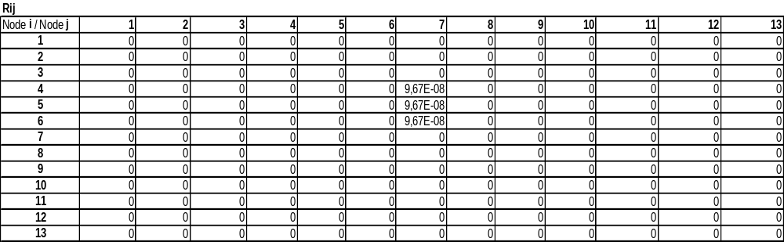

4.2.3) Input table N° 4 : Sun Impact Si (W)

4.2.4) Fluid loop heat transportation coefficient:

180 W / °K > m.dot*Cp > 130 W/°K according to NPO-PM data

130 W / °K taken in the calculations for all m.dot * Cpif (main stream) or m.dot * Cpif * BP (by-pass stream) or m.dot * Cpif * (1-BP) (cooling stream)

4.2.5) By-pass ratio

For mathematical reasons (division by 0), by- pass ratio BP cannot be either 0 or 1

For physical reasons, by-pass ration cannot be 1, because with 100% of the main stream flowing through the by-pass (= no radiation cooling at all), temperatures rise to infinite.

4.2.5 ) Results with BP = 0,01 after ~ 8000 steps iteration and Kn +1 = 0,1 :

remark 1: K n+1 was decreased to 0,1 although convergence was very fast with Kn+1 = 0,5 , because total energy balance fulfilled the convergence criteria , but not the energy balance of nodes 4, 5 and 6. With K n+1 = 0,1 more iterations are performed and energy balance in nodes 4, 5 and 6 is respected.

Remark 2: node 1 does not represent in fact the payload temperature, but the temperature of the outer skin of the fluid loop tube (NPO-PM definition). The same is valid for the radiation nodes 4, 5, 6.

The fluid loop analysis diagram is automatically generated on the sheet “Loop” of the Excel tool

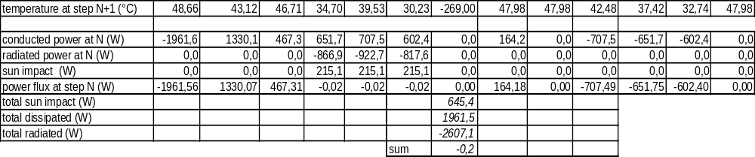
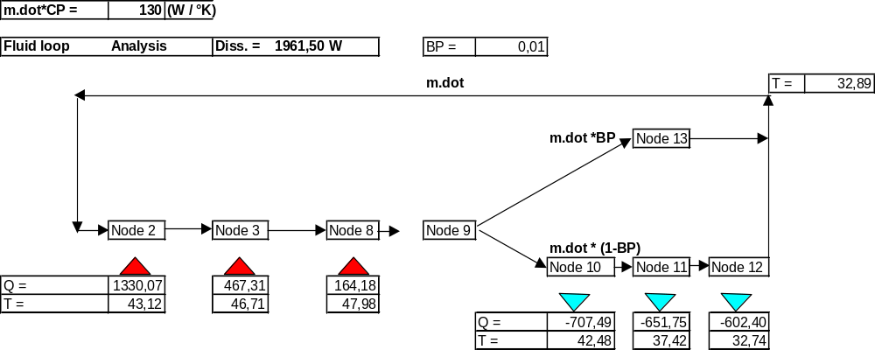
4.2.6) Other results

Some calculations have been performed to check the efficiency of the fluid loop by-pass in its role to regulate the entry temperature of the main stream (upstream of node 2), calculated as TE = (BP*T13f ) + (1-BP)*T12f

First, the By –pass coefficient BP has been varied with full dissipation (1961,5 watts). Depending on the qualification temperature of the fluid and of the by-pass actuator, up to 60 °C temperature elevation seem achievable.
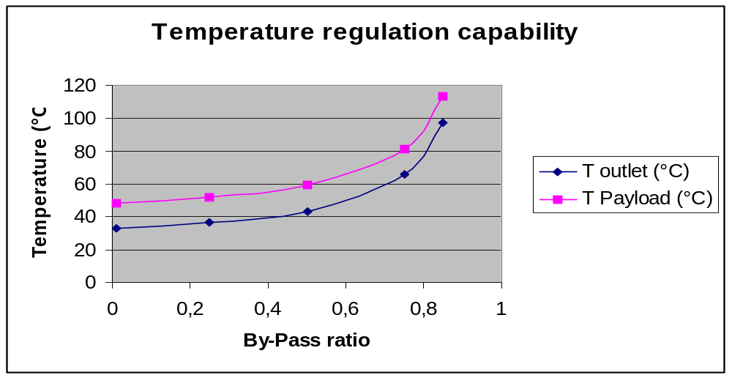

Second , the by-pass was used to maintain the inlet temperature of the main stream for decreasing dissipations in node 1 (100% of max, 75 % and 50%)
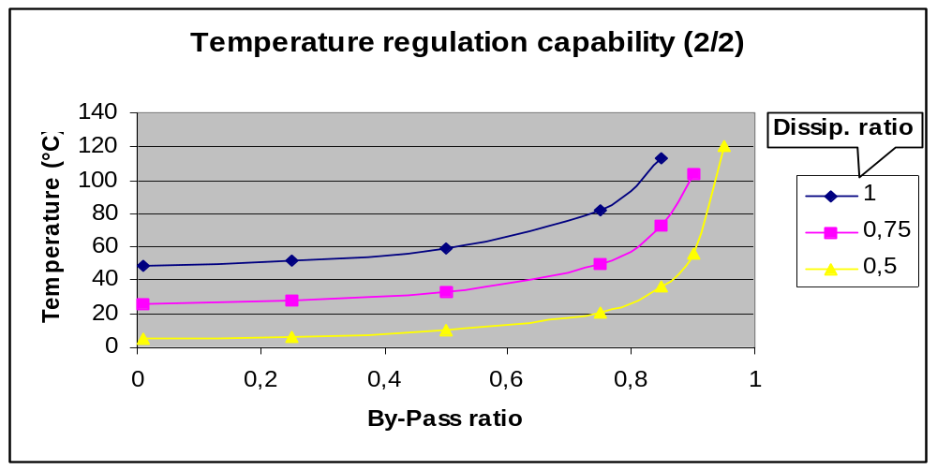
5) How to run the program:

  - On page “Input”, write in line 18 the temperatures (°K) at step n = 1 for all nodes 1 to 6.
  - The lines 20 and 21 are automatically and (almost) simultaneously calculated
  - Push the button “iteration “ and let it run : the program stops when temperatures in lines 18 and 21 are equal with less than 0,01 ° difference and the total energy balance in cell I 31 is less than 0,2 W in absolute value.
  - If the energy balances for each node are not correct (for non dissipative & non radiative nodes, the energy balance must be around zero) but the convergence criterias has been achieved, perform a new run with some temperatures changed by 1°K as input in line 18.
  - The Iteration loop is automatically stopped after:
    - 25 000 iterations and no convergence
    - divergence (a “bug” window opens automatically)
  - If convergence can be reached above 25 000 iterations, just push again iteration button..
  - Otherwise, the convergence process can be insured via the coefficient Kn+1 (D7) on the “Input” sheet. In line 20 “intermediate temperature”, the mix (Kn+1* Tn+1) + (Kn*Tn) is calculated and reinjected as new input temperature Tn by the Iteration macro. One should start with Kn+1 = 0,5 , but may have to decrease Kn+1 to 0,01 (case of By-Pass ratios above 95 % !)
  - If the formulas are wrong, of course no convergence can be obtained.

6) How to modify the model and the program:

  - “Input” sheet can be modified by adding columns (nodes). Column DD shall be the last one (iteration inside the iteration macro goes up to column DD)

  - in the “Input” table and for each node, lines 12 to 17 must be filled in with node data

  - in the “Input” table and for each node, line 20 must be modified according to the formulas [8] or [9], using the intermediate results extracted from Conduction Matrix, Radiation Matrix and Sun Impact Excel sheets

  - in the “Input” table and for each node, lines 24 to 31 must be modified according to the formulas written in the cells, using the intermediate results extracted from Conduction Matrix, Radiation Matrix and Sun Impact Excel sheets

  - in fact, the program has to be updated progressively as the number of nodes increases

Have fun ! ☺

Author: M. Perdu , 21 / 06 / 2007

